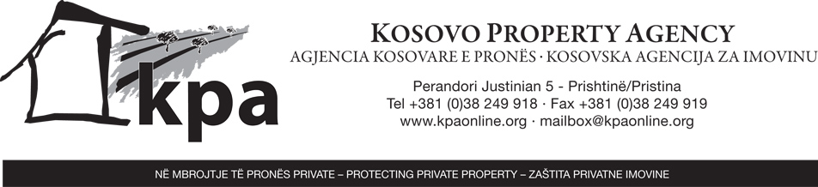

PRESS RELEASE

14 October 2010

The Assembly of the Republic of Kosovo in the plenary session held on 30 September 2010 appointed, upon the nomination of the Prime Minister of Kosovo, the two Local Members of the Supervisory Board and the Deputy Director of the Executive Secretariat of the Kosovo Property Agency (KPA) pursuant to the Assembly of Kosovo Law No. 03/L-079.

The members of the Supervisory Board who were appointed for a term of one year are: Mr. Ujup Krasniqi and Mr. Rexhep Kelani.
The appointed Deputy Director of the KPA Executive Secretariat Mr. Xhevat Azemi.

The KPA was established as an independent Agency by the promulgation of UNMIK Regulation 2006/10 on the Resolution of Claims Relating to Private Immovable Property, Including Agricultural and Commercial property. UNMIK Regulation 2006/10 was amended by UNMIK Regulation 2006/50 of the same name which provided the Agency with a clear mandate and a division of roles between its three main bodies, namely the Executive Secretariat, the Kosovo Property Claims Commission (KPCC) and the Supervisory Board. Following the entering into force of the Constitution of the Republic of Kosovo in June 2008, UNMIK Regulation 2006/50 was adopted and amended by this regulation is amended and adopted by the Assembly of Kosovo Law No. 03/L-079

The KPA is mandated to receive and register and through the KPCC to resolve claims resulting from the armed conflict that occurred between 27 February 1998 and 20 June 1999 in respect of private immovable property, including agricultural and commercial property. Decisions taken by the KPCC are subject to a right of appeal only to the Supreme Court of Kosovo.

For further information please contact:
Mr. Arian Krasniqi
Information Officer
Arian.krasniqi@kpaonline.org
Phone: +381 (0)38 249 918 ext. 230
Mobile phone: +377(0)44 300045

